**ארכיטקטורה ותיכון**

קבוצה 15

Architecture

**DB Firebase**

stores :

* Volunteer
* Places
* Phone number

**Application**

* login
* Home page
* admin panel
* Add volunteer
* update volunteer
* view all volunteer
* User event management
* create event
* view all the volunteers to the event

**Firebase**

* Database management
* Volunteer management

API

**DB Calendly**

stores :

* events
* Volunteer

**Calendly**

* Volunteer data

API

Detailed design of the DB components

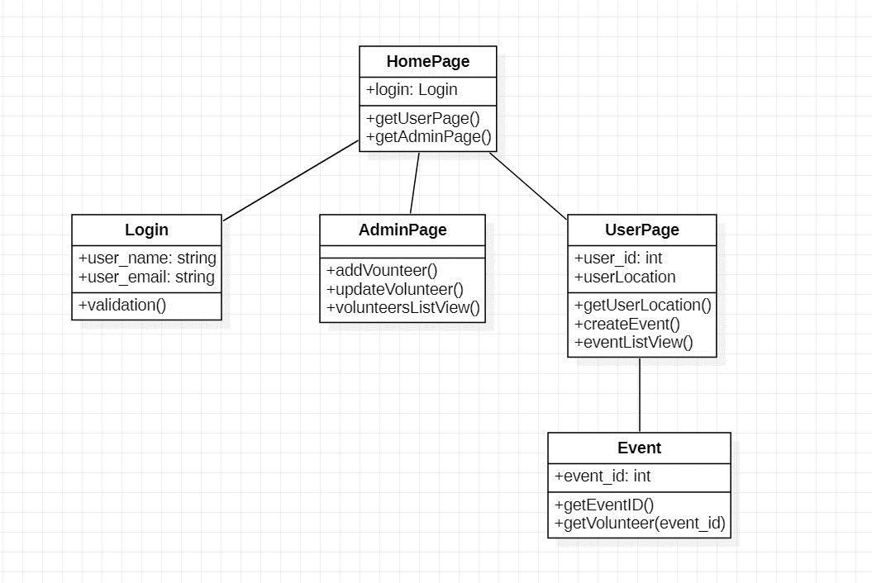

Risk Assessment

**.**

|  |  |  |  |  |  |
| --- | --- | --- | --- | --- | --- |
| Risk Code | Impact | Prob | Type | Description / Impact | Name |
| 4 | H | 15% | Team | The time period will not be enough to complete the requirements | Time |
| 3 | H | 30% | Development | A programming language that team members are unfamiliar with | Programming language |
| 1 | VH | **8**0% | Development & Product | New or updated client requirements | Requirements |
| 4 | L | **45%** | Team | Work together remotely because of the COVID-19, delays because of this | COVID-19 |